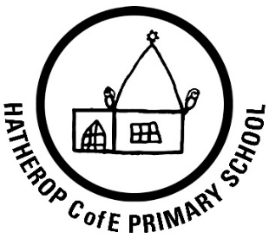 | Hatherop Church of England  Primary School  Hatherop, Cirencester, Gloucestershire, GL7 3NA  Tel: 01285 750318  Email: admin@hatherop.gloucs.sch.uk  Website: https://www.hatherop.gloucs.sch.uk/  Headteacher: Mrs T Hancock  ‘Caring, Believing, Achieving’

Newsletter: 4th January 2021

Welcome back and a happy new year to you all. I hope you all had a restful and enjoyable Christmas holiday and that the children are all ready for their return tomorrow!

I’m sure you have been following the news over the past few days and clearly there is a lot of uncertainty around the safety of schools reopening. Today we have looked again at our risk assessment and made the necessary updates in order to keep the school as safe as we possibly can for all our community. We will start the term off with an assembly reminding the children of the expectations and how they can minimise risk. In preparation for their return, I ask that you reinforce the messages about keeping safe, washing hands, maintaining a safe distance when possible and dressing warmly so that we can keep the school well ventilated. In addition, please adhere to the drop off and pick times and procedures and move quickly out of the school grounds at the end of the day.

This term our Christian value is Respect. We think of the story of Moses as he approached the burning bush.
‘As Moses approached the presence of God in the burning bush, God said to him: ˜Do not come any closer. Take off your sandals, for the place where you are standing is holy ground.’
This scene captures something of the essence of ˜reverence’ and ‘respect’. Respect for God extends to respect for all creation, including all people(and ourselves), animals and our environment. In school children and adults are expected to show respect for each other, their belongings and their environment. These are themes that will all be explored over the coming weeks.
We are looking forward to starting a new approach to teaching creative writing this term. Today staff have attended ‘The Write Stuff’ training. This is a programme which uses good quality texts to inspire writing. Often, we find that teaching writing is one of the most difficult parts of the curriculum. Staff are excited at the prosect of using new texts and a new teaching model to improve writing across the school.

We look forward to seeing you and all the children tomorrow.
‘
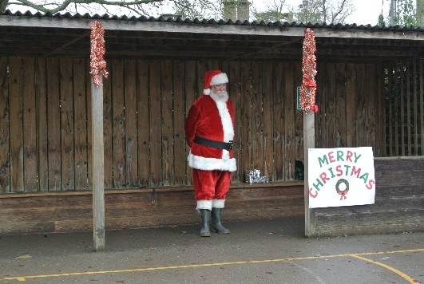  We were very fortunate that Santa was able to pay us a visit last term. He met all the classes in the playground for a chat. | Progress Award  Congratulations to Isaac Reynolds on receiving the progress award this term. His improvements and progress in all areas of the curriculum have been commendable.  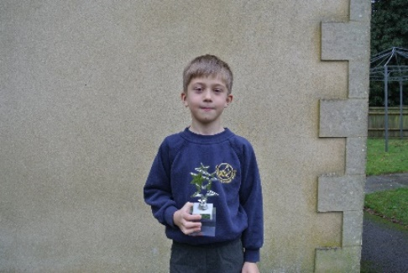
House Points
Children continued to collect house points last term, for work well done, recognition of good behaviours for learning, reading, good manners and many other reasons!
The progress towards 100 points and treat day is as follows:

Keble – 49 Cook – 58 Farmor – 62

Congratulations to the children who received their bronze awards this term:

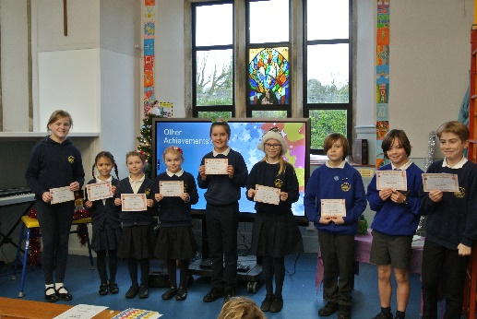
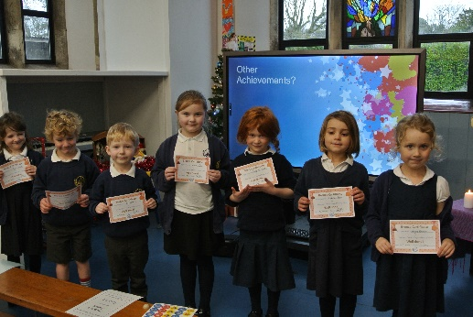
Thankfulness Awards
This term our value was thankfulness. The teachers nominated children who had demonstrated living out this value in school. The recipients of the thankfulness certificates were:
Year R – Willa, Year 1- Maggie , Year 2-Nina , Year 3- Orla, Year 4- Ebba, Year 5- Gracie, Year 6 – Grace
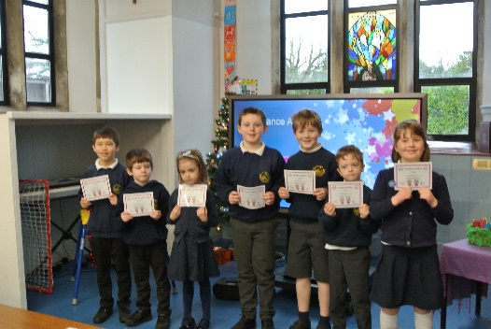
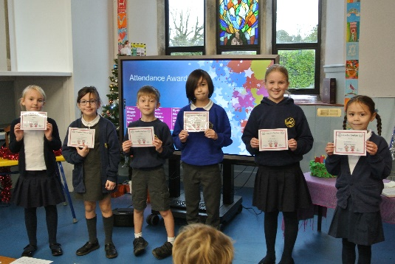
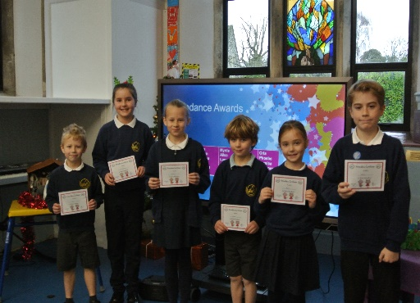
Attendance:

Well done to all these children who achieved 100% attendance since September. This is something to be proud of during these tricky times!
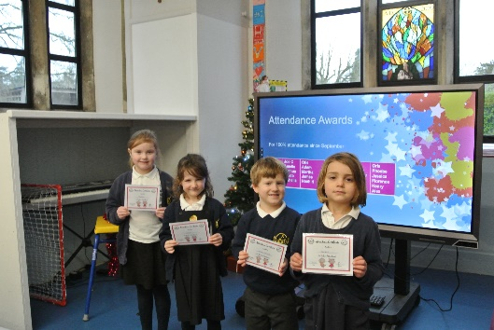
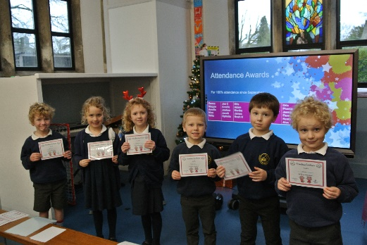

Dates for the Diary:
5th January 2021 | Return to school
8th January 2021 | Year 5/6 Schoolbeat Officer Visit
9th February 2021 | Safer Internet Day
12 February 2021 | Last day of Term
22nd February 2021 | INSET day
23rd February 2021 | Return to school
25th February 2021 | Chance to Shine Cricket
1st April 2021 | Last Day of Term 2pm Finish
19th April 2021 | Return to School
27th May 2021 | Last day of term
28th May 2021 | INSET day
7th June 2021 | Return to school
1st July 2021 | Year 5/6 Schoolbeat Officer Visit

