**Science**

Seasonal changes

* Observe closely, using simple equipment
* Use observations and ideas to suggest answers to questions
* Observe changes across the 4 seasons
* Observe and describe weather associated with the seasons and how day length varies

**Literacy**

* Recounts
* Narrative- Hansel and Gretel
* Information Books
* Phonics
* Using the suffixes –ing, -ed, -er, -est
* ‘I can tell you what a verb is’

**Maths**

Number

* Count to and across 100, forwards and backwards, beginning with 0 or 1, or from any given number.
* Count, read and write numbers from 1-100 in numerals and words.
* Represent and use number bonds and related subtraction facts within 20.

Shape, Space and Measure

* Order two or three items by capacity.

**‘Enchanted Woodland’**

**Term 5**

**Art/DT**

* Flowers: Mother Nature as Designer
* Drawing techniques
* William Morris
* The Work of Gustav Klimt

**Computing**

* E-safety
* Recognise common uses of information technology beyond school
* Use technology purposefully to create, organise, store, manipulate and retrieve digital content

**Skylark Class**

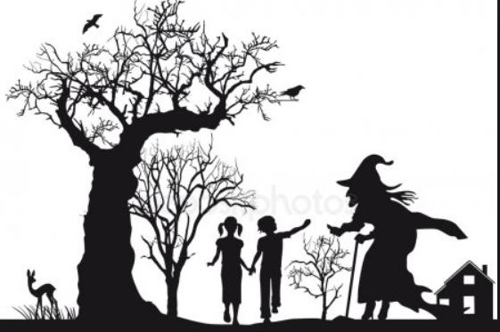

**History/Geography**

* Simple compass directions
* Where Do I Live? -I can understand where I live in the local area
* Use simple observation/fieldwork skills
* I can look at aerial photographs
* I can locate our school

**RE**

* Value: Trust
* Judaism

**Music**

* Listen and Appraise
* Singing, improvising and playing classroom instruments

**PE**

* Balance/agility
* Tactical games
* Team games

**PSHE**

* Value of the Term: Trust
* Unkind, tease or bully?
* Who can help?
* Pass on the praise!