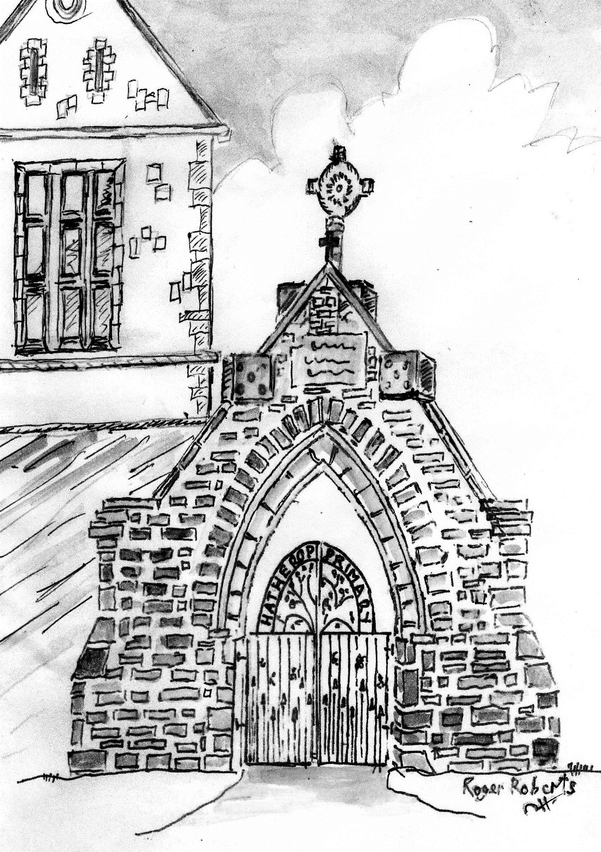
Hatherop Primary School Auction of Promises
Catalogue
Friday 23rd November

- Drinks served from 7.00pm
- Canapés courtesy of Lynwood & Co
- Entertainment by Andy Cole,
- Magic Circle Magician
- Philip Allwood, auctioneer

- Bidding commences 7.30pm

Auction Lots:
1 | Tickets for 2 children and 2 adults for Adam Henson's Cotswold Farm Park | Adam Henson
2 | 2 x one hour massage session | Sally Peachey
3 | 3x Pilates sessions at The Pilates Barn | Jenny Iles
4 | One hour clay pigeon shooting lesson with Dave Harris. Age 10 plus. | Dave Harris
5 | Burford Wildlife Park Tickets for 2 adults and 2 children | Wildlife Park
6 | 3 x one hour tennis coaching with level 3 licensed coach for 4 children | Helen Owen
7 | Mosaic making for 4 children age 5 plus with a birthday tea | Judy Francis
8 | A morning at Donkeywell Forge making an iron work item | John Ward
9 | 2 hours dog obedience training with Dave Harris | Dave Harris
10 | A 12lb Christmas turkey | Cutler & Baylis
11 | A ham for Christmas (feeds 6] | Cutler & Baylis
12 | A marzipanned and iced Christmas cake | Jo Strong
13 | Afternoon tea at The Wolseley, Piccadilly | Ginette Chalmers
14 | 6 bottles of Sloe Motion gin Mr and Mrs Kennedy | Mr & Mrs Kennedy
15 | 6 bottles of Nicholas Feuillatte champagne | Mr & Mrs Kennedy
16 | A 5 foot non needle-drop 'Nordman' Christmas tree from Garden & Plant Co. | Jeremy Weston
17 | A Christmas pud | Verity Gardiner
18 | An hour's magic tricks by Andy Cole, member of the prestigious 'Magic Circle', for an adult party or function | Andy Cole
19 | A sterling silver piece of jewellery | Albee Yeend
20 | A stunning Liberty Vase | Ginette Chalmers
21 | A Coln Stores Christmas hamper | Coln Stores
22 | Voucher for £100 to be redeemed in one transaction at The New Inn | New Inn, Coln
23 | A week in a Cornish holiday cottage in Port Gaverne (100 yards from safe cove and award-winning restaurants, close to Port Isaac, Padstow and Polzeath). Sleeps 4. October half-term available, or date to be arranged | Judy & Mike Francis
24 | Half a day's sailing experience for 2 at Bowmoor Sailing club, Lechlade | Bowmoor
25 | A brand new boxed mini4 iPad 128 GB from Go-Compare | Lauren Nolan
26 | A framed embroidery by Jane Greenoff | Caroline Burton
27 | A Nespresso compatible coffee machine x2 | Dan Jones
28 | A taupe leather Givenchy handbag | Anne Robinson
29 | Three-course supper party for 6, delivered to your house | Edwina Hicks
30 | A taxi to and from local party or function (15 mile radius] | Nick Owen
31 | Photo session for a family group portrait | Piers Belmont
32 | A personalised rainbow cushion | Helen Forbes
33 | Lunch for 2 and a bottle of wine at Made by Bob | James Parkinson
34 | A pair of iron work candlesticks designed from pump parts, forged at Xylem | Xylem
35 | A mini make-over with CMB Cosmetics, plus a free lipstick | Liz Partington
36 | One hour's grass cutting | Mike Harris
37 | A £50 voucher for Fairford Opticians | Robin Worthington
38 | A children's tea party for 8 in a tree house | Kate & David Hicks Beach
39 | A tour for 4 round Arkell's brewery including beer tasting and hot/cold food | Arkell family
40 | One hour lesson for two at Barbury Shooting School | Barbury Shooting
41 | One hour's rose or small shrub pruning | Laura Emmerson
42 | Deluxe three-tier chocolate cake (serves 12) | Bridget Upton from 'Bake!'
43 | 24 hour babysitting – have a night away! One family of children only | Martha Flood
44 | 3 singing lessons with a professional singer | Kate Hicks Beach
45 | A handy man for 2 hours in your own home [materials not provided] | Julian Wilder
46 | 10 sessions for a toddler at Happy Beans | Lizzie Skinner
47 | 2 Yoga sessions | Ali Parkinson
48 | Have a basket full of ironing done for you | Joe Upton
49 | A day's Fly Fishing on the River Coln | Johnny Reeves
50 | 2 hour session (Quenington) with a child-friendly pony to include grooming and a led ride for 1 or 2 children – max weight 8 stone | Penny Ibbotson
51 | 3 course dinner for 6 (excluding drinks) delivered within 10 miles of Quenington | Kate Roberts
52 | A children's birthday cake | Alison Dugdale
53 | A framed picture (by Roger Roberts) of The Vic at Eastleach | Roger Roberts
54 | 4 pairs of Hector & Queen pyjamas age 7-8 | Bettina Harvey
55 | 10 oven-ready partridges | Paul Freebury
56 | 10 oven-ready pheasants | Paul Freebury
57 | An 8 inch marzipanned/iced Christmas cake by the chef from Williamstrip Park | The Chef
58 | 2 dozen mince pies | Anna Freebury
59 | A handmade Christmas wreath for your door | Rosie Emmerson
60 | 2 adult tickets for the Royal International Air Tattoo (children under 17 go free) | RIAT
61 | Sunday lunch for 4 at The Keepers, Quenington | John Gardiner
62 | A tray bake of deluxe award winning ginger tiffin by our youngest contributor | Violet Turnbull (9)
63 | 2 lots of freezer meals: frozen lasagne for 6 and frozen beef casserole for 6 | Jo Perkins
64 | A night stay at The Mason's Arms, Meysey Hampton (not including Breakfast) | Paul Fallows
65 | Deer stalking with Dave Harris, courtesy of Mr & Mrs Kennedy, Williamstrip Park | Mr & Mrs Kennedy
66 | Running with Rob – as far as you like/can, with helpful hints and tips on running | Rob Forbes
67 | A 1-1 Personal Fitness Training session | Hayley Hurdle
68 | One hour 'Try Dive': a scuba diving experience at Cirencester pool (must be able to swim 2 lengths and minimum age 14) | Mike Ibbotson
69 | 5 hours of French or Spanish tutoring: from basic conversational to A Level | Laura Hubbard-Miles
70 | One and a half hour's cricket training at Williamstrip Cricket Club | Ian Powell
71 | A cake for a special occasion | Albee Yeend
72 | Initial consultation and 2 follow-up treatments at The Family Osteopath, Fairford | Ben Court
73 | A Herb Book signed by Judith Hann | Judith Hann
74 | Original artwork by digital artist Izzy Burton, winner of Best Animation Film at the Florence (Firenze) Film Festival 2018 | Izzy Burton
75 | A three-course meal for two at The Sherborne Arms | Mr and Mrs Jenvey
76 | Mixed half case of wine | Helen & Dave Cuthbertson
77 | A New Year's Eve box of treats | Ellen Ewens & Hannah Turnbull
78 | A cut and blow dry at Mr Ernest Hair Stylist, Fairford | Mr Ernest
79 | £20 voucher for Andrew Butler Butchers, Fairford | Butler Butchers
80 | A framed, original painting by Cotswold artist Louise Bird | Caroline Burton
81 | 2 hour henna tattooing session at a venue of your choice | Tash & Lucy
82 | 90 minute tour for 4 of exclusive behind the scenes Oxford gems, including the Bodleian and Radcliffe Camera | Stephanie North
83 | 70 minute full-body Aromatherapy – calm and relax both your mind and body at the Complete Health Centre in Cirencester | Melanie Bowers

More exciting promises to come!

Auction of Promises 2018
Through our Auction of Promises, we hope to raise much-needed funds for essential school resources. Top of our wish list is to improve the provision of IT, including new iPads and Chrome Books that will replace the ageing laptops our children struggle to operate effectively. In addition, the school also faces significant costs to improve the school grounds and building, including essential alterations to the pedestrian and vehicle entrance, the school garden, the nature area and the boundary stone walls.
This catalogue has a wonderful selection of promises, some of them truly unique, reflecting the broad diversity of our community. We hope you will find one or more things that you would like to bid for – some of them will make exciting and original Christmas presents!
What a lovely coincidence that we have 83 Promises and there are 83 children at Hatherop CofE Primary School!
We are all very grateful for your support.
Caroline Burton
Head Teacher

Conditions of Sale
How to bid: Everyone attending the auction will receive a bidding number and will be asked for their name and contact number. Successful bidders should clearly show their bidding number to the Auctioneer.
Anyone unable to attend who wishes to make a pre-auction bid, should contact the school on 01285 750318 or email Louise Cowan on lcowan@hatherop.gloucs.sch.uk giving your name and contact details.
Payment: We would request that all lots be paid for on the evening with the exception of outside bidders who will be contacted after the auction.
Promises can be paid for by cash or cheques made payable to Friends of Hatherop Primary School.
Receiving your promises: Following your successful bid, you will be given an envelope with your voucher and contact details. All promises must be taken within a year of the auction and it is your responsibility to contact the donor. The promises have been given in good faith and descriptions have been worded as accurately as possible.
Bar: During the evening, drinks and canapés will be available – donations will be gratefully received.

