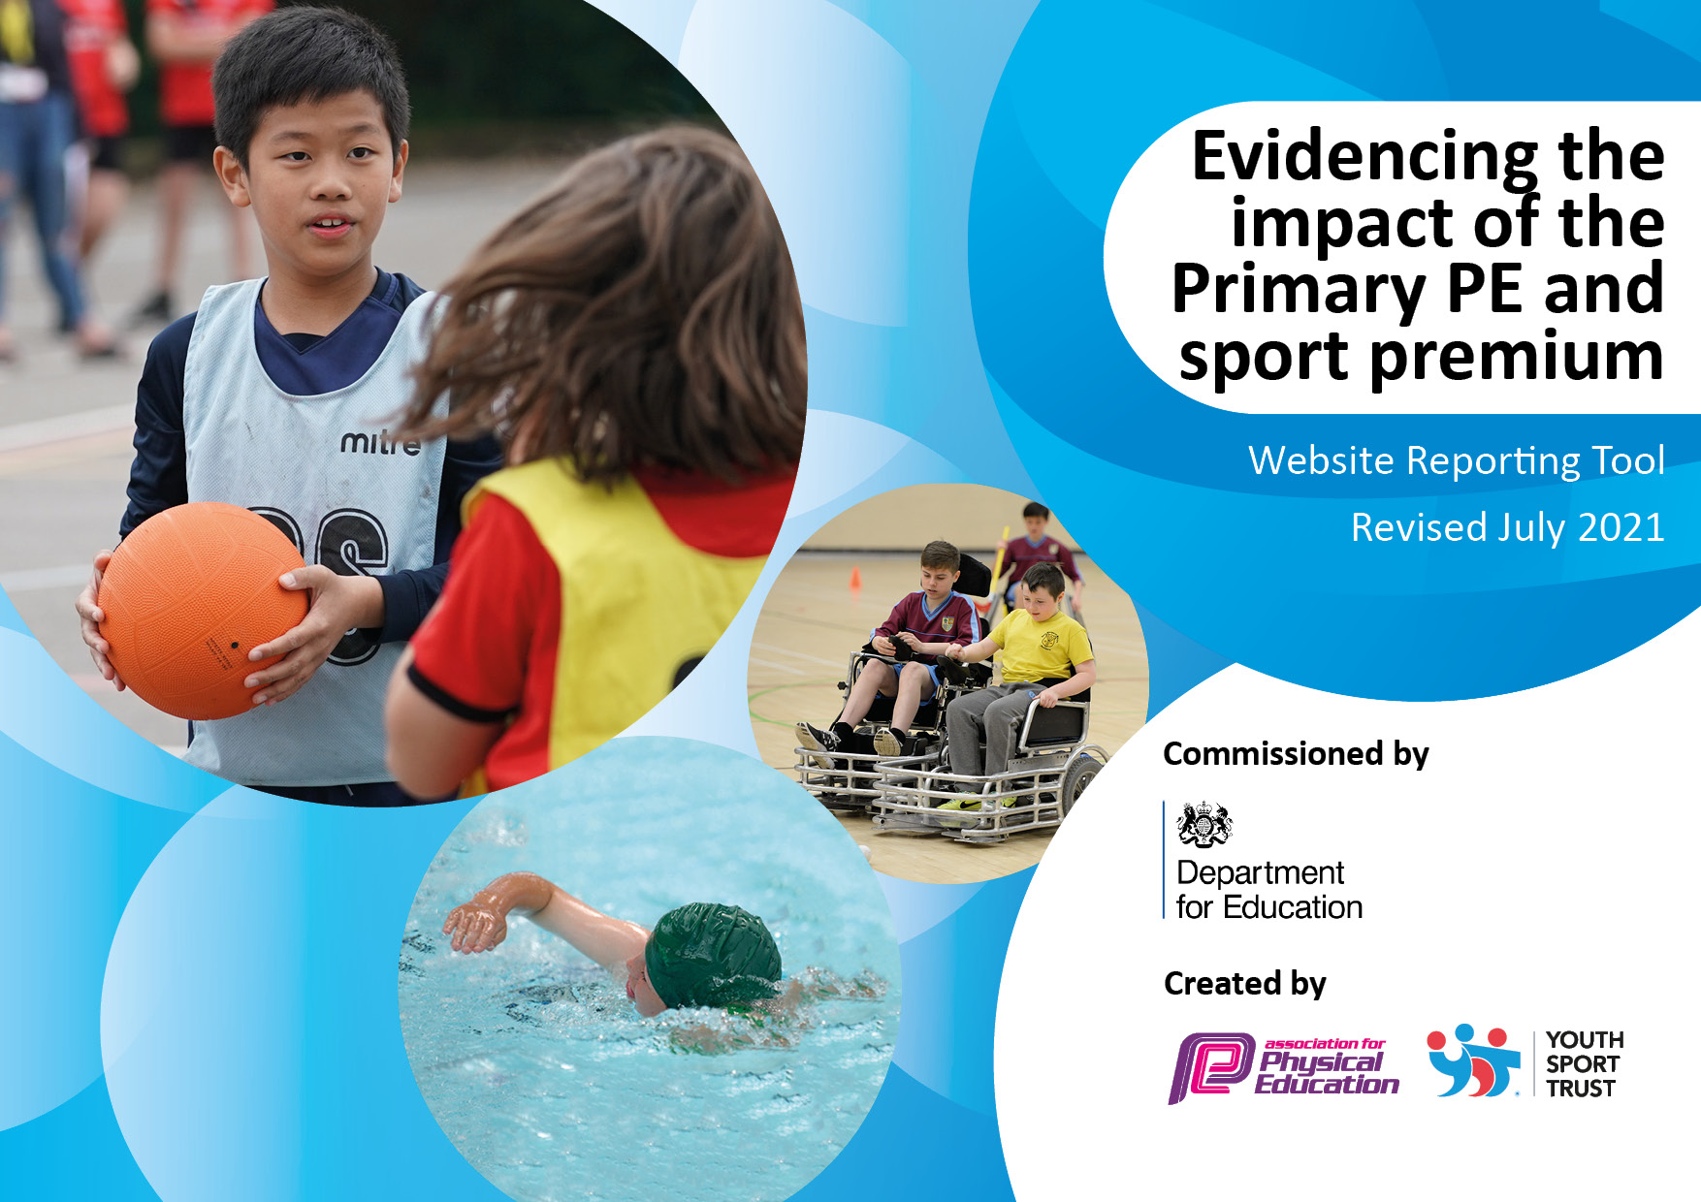

Details with regard to funding
Please complete the table below.

Total amount carried over from 2019/20 | £ 453
Total amount allocated for 2020/21 | £ 16 710
How much (if any) do you intend to carry over from this total fund into 2021/22? | £ 8 226
Total amount allocated for 2021/22 | £ 24 918
Total amount of funding for 2021/22. To be spent and reported on by 31st July 2022. | £24 918
Swimming Data
Please report on your Swimming Data below.

Meeting national curriculum requirements for swimming and water safety.
N.B. Complete this section to your best ability. For example you might have practised safe self-rescue techniques on dry land which you can then transfer to the pool when school swimming restarts.
Due to exceptional circumstances priority should be given to ensuring that pupils can perform safe self rescue even if they do not fully meet the first two requirements of the NC programme of study
What percentage of your current Year 6 cohort swim competently, confidently and proficiently over a distance of at least 25 metres?  N.B. Even though your pupils may swim in another year please report on their attainment on leaving primary school at the end of the summer term 2020.  Please see note above | 100%
What percentage of your current Year 6 cohort use a range of strokes effectively [for example, front crawl, backstroke and breaststroke]?  Please see note above | 100%
What percentage of your current Year 6 cohort perform safe self-rescue in different water-based situations? | 100%
Schools can choose to use the Primary PE and sport premium to provide additional provision for swimming but this must be for activity over and above the national curriculum requirements. Have you used it in this way? | Attendance at Competitive Gala and preparations for the event.

Action Plan and Budget Tracking
Capture your intended annual spend against the 5 key indicators. Clarify the success criteria and evidence of impact that you intend to measure to evaluate for pupils today and for the future.

Academic Year: March 2021- July 2022 | Total fund allocated: £24 918 | Date Updated: July 2022
Key indicator 1: The engagement of all pupils in regular physical activity – Chief Medical Officers guidelines recommend that primary school pupils undertake at least 30 minutes of physical activity a day in school |  |  |  | Percentage of total allocation:
 |  |  |  | £1500 = 6%
Intent | Implementation |  | Impact
Your school focus should be clear what you want the pupils to know and be able to do and about  what they need to learn and to  consolidate through practice: | Make sure your actions to achieve are linked to your intentions: | Funding allocated: | Evidence of impact: what do pupils now know and what can they now do? What has changed?: | Sustainability and suggested next steps:
To maximise engagement throughout the day  To deliver ‘Huff Puff’ play for KS 1 pupils | Enhance the play time provision so that pupils are physically active and engaged during playtimes and lunchtimes by:  Providing a rota of a variety of equipment such as skipping ropes, bats and balls, footballs, hoops etc  KS1 pupils are directed in the play by a TA for 15min per day.  This takes place straight after lunch each day and is led by a TA who knows the pupils well and is able to encourage them to develop their skills and to try new things. | £500  £600 – TA  £400 Equipment | Pupils are engaged in active play at playtimes/lunchtimes using a variety of equipment such as balls, hoops, skipping ropes. Play leaders get the equipment out and encourage younger members of the school community to take part in games which require physical activity.  KS1 Pupils are active for an additional 15 min per day and learn new skills as directed by a TA | CPD for lunch time supervisors to become ‘play leaders’  Further activity zones for an all inclusive playground, with different zones/areas of interest.  Update equipment when needed.
Key indicator 2: The profile of PESSPA being raised across the school as a tool for whole school improvement |  |  |  | Percentage of total allocation:
 |  |  |  | £9000= 37% + +/- £3700 EYFS
Intent | Implementation |  | Impact
Your school focus should be clear what you want the pupils to know and be able to do and about  what they need to learn and to  consolidate through practice: | Make sure your actions to achieve are linked to your intentions: | Funding allocated: | Evidence of impact: what do pupils now know and what can they now do? What has changed?: | Sustainability and suggested next steps:
To maximize the amount of pupils who value Sport for fitness and enjoyment  To improve the EYFS outdoor area – September 2023 | Offer a wider range of sporting clubs and lessons, focusing on Team sports  To employ a Sports Specialist coach for an afternoon per week to support sports development  Children to write sports reports which are celebrated in the Newsletter and published and published on the school website  Equipment to be reviewed and updated, specialist equipment for chosen sports.  Host the interschools football tournament  Provide more opportunities for the EYFS/Year 1 class to have continuous provision for physical activity | £9 000 – salaries as well as payment for extra hours attending sporting events  Remaining budget- after August reconciliation  +/- £3700 | Pupils are all aware of the sports on offer, take part as much as possible and are confident to share their achievements.  Pupils have taken part in a huge variety of sports both as clubs within school as well as competitive sports at district and county level. Sport include netball, tag rugby. Rounders, swimming gala, athletics, football, cross county.  Additional opportunities for KS 1 to participate in clubs. 2 x clubs offered per week in the summer term with the specialist sports coach.  To be implemented in September | Maintain connections with the local sports school in order to continue to participate in as many events as possible – to continue to provide opportunities for all.  Arrange more inter-school events with other local small schools.  In the summer term, Hatherop achieved their Gold Sports Mark Award. – maintain the standards required

Key indicator 3: Increased confidence, knowledge and skills of all staff in teaching PE and sport |  |  |  | Percentage of total allocation:
 |  |  |  | £1200 = 5%
Intent | Implementation |  | Impact
Your school focus should be clear | Make sure your actions to | Funding | Evidence of impact: what do | Sustainability and suggested
what you want the pupils to know | achieve are linked to your | allocated: | pupils now know and what | next steps:
and be able to do and about | intentions: |  | can they now do? What has
what they need to learn and to |  |  | changed?:
consolidate through practice:
Children to be engaged and stretched by well thought out and thorough PE sessions at least twice a week. These may take the form of a double session on the same day | Purchase of a new PE Scheme with video clips to demonstrate good practice and offer professional advice. Sports Specialists to be employed to work alongside the class teacher/TA or HLTA.  Resources purchased to support the delivery of the scheme.  Additional subject leader non contact time | £500  £500  £200 | The use of a recommended PE Curriculum,(Get Set for PE)ensures that there is more consistency to the delivery of lessons and that the progression of skills is cohesive throughout the school.  PE is mapped out for all classes and all stands to be covered across the year.  Teachers report that the resources are easy to use and enable non specialist teachers to teach PE more effectively. | Use of CPD materials to improve staff confidence and skills further
Key indicator 4: Broader experience of a range of sports and activities offered to all pupils |  |  |  | Percentage of total allocation:
 |  |  |  | £3544= 15%
Intent | Implementation |  | Impact
Your school focus should be clear | Make sure your actions to | Funding | Evidence of impact: what do | Sustainability and suggested
what you want the pupils to know | achieve are linked to your | allocated: | pupils now know and what | next steps:
and be able to do and about | intentions: |  | can they now do? What has
what they need to learn and to |  |  | changed?:
consolidate through practice:
Experience a wider variety of sports and health programs  To participate in additional sport using an outside providor in order to broaden provision  To participate in Outdoor Learning (forest school) throughout the year and in all weathers | To employ the Sports Project to run a 10 week (Summer) and 12 week (Autumn) programme with classes as well as identified pupils to work on skills such as team work, resilience and communication.  Targeted children to experience a range of sporting opportunities in small groups (SEND and PPFSM)  Focus upon greater use of sports to engage in the wider curriculum  Close planning with class teachers to support specific pupils  To work with Up and Under Sports to incorporate an opportunity for a breakfast sports club as well as a session for each class to participate in.  TA supported the class for consistency and CPD.  Work with the ECT to use part of their land to support outdoor learning  CPD for all staff  Sessions for all classes to attend – 1 day per month for the year. | £1270  (Summer 2021)  £1524  (Autumn 2021)  £750  Summer 2022#  Transport to the woods £2 000 | Post lockdown pupils have showed that they were struggling to work as a team effectively. They were less resilient and need support to work collaboratively.  After attending the 10 week programme we could see marked improvement and application of the skills that they had learnt being transferred to the classroom  Specific pupils who were identified as being affected most by the pandemic had small group work specifically planned to their needs. Teachers and parents both reported a positive impact with children being more engaged and showing more resilience and perseverance.  Both KS1 KS2 pupils attended breakfast sports club, which set them up well for the day ahead at school.  All pupils participated in additional sports sessions – 45 min extra physical activity per week.  Staff are now more confident and skilled to be able to use the outdoor area on site to enhance learning. All staff attended and supported learning led by ECT. | Staff were involved in the planning phase with the Sports Recovery programme so that they could continue the work post the 10 week programme.  .  TA’s attended the sessions for their own CPD and to support pupils.  Continue to work with ECT to maintain,  Further develop our own outdoor area.

Key indicator 5: Increased participation in competitive sport |  |  |  | Percentage of total allocation:
 |  |  |  | £5000 = 20%
Intent | Implementation |  | Impact
Your school focus should be clear | Make sure your actions to | Funding | Evidence of impact: what do | Sustainability and suggested
what you want the pupils to know | achieve are linked to your | allocated: | pupils now know and what | next steps:
and be able to do and about | intentions: |  | can they now do? What has
what they need to learn and to |  |  | changed?:
consolidate through practice:
All KS2 children to take part in competitive sport throughout the year | Funding to release staff members to accompany & Liaise with Sports specialist & events calendar to attend as many events as is possible. | £ 2 000 salaries  £3000 transport | Opportunities to participate in competivive events each term including, netball, rounders, cricket, athletics, football, Tag Rugby, cross country.  Typically when attending such events, we do very well often securing first place.  Some examples of this are:  When attending a cross country event we achieved first place in one ages group and second place in another. Celebrated in worship and certificates to be given out in celebration worship. Photograph of the was published in the newsletter and on the website as well as a local publication.  Netball competition- team won 6/7 games and drew the final game.  2 different teams sent so that as many pupils as possible could have the opportunity to take part.  Success at the gala and district sports in the summer term with many of our pupils progressing on to area sports.  In the summer term, Hatherop achieved their Gold Sports Mark Award. | We will continue to engage with Kingshill to ensure that we take part in as many events as we can in the year ahead.

Signed off by
Head Teacher: | Taryn Hancock
Date: | April 2021 Updated Nov 2022 Updated Jan 2022/March July 2022
Subject Leader: | Di Clarke
Date: | April 2021
Governor: | Camilla Bowring
Date: | July 2022

