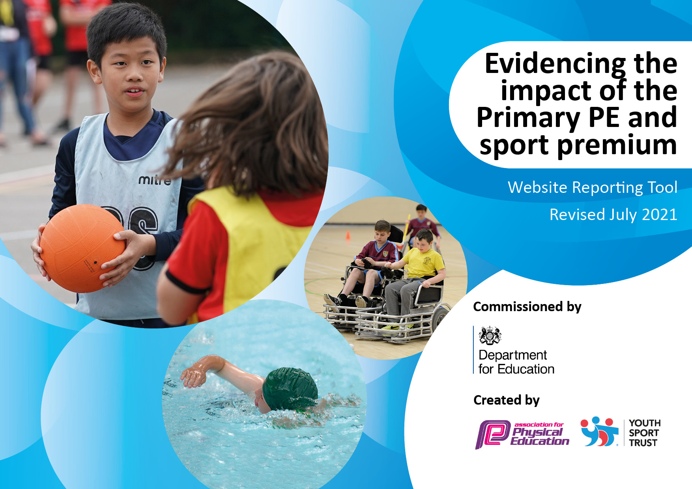

Details with regard to funding
Please complete the table below.

Total amount carried over from 2019/20 | £ 453
Total amount allocated for 2020/21 | £ 16 710
How much (if any) do you intend to carry over from this total fund into 2021/22? | £ 8 226
Total amount allocated for 2021/22 | £ 24 918
Total amount of funding for 2021/22. To be spent and reported on by 31st July 2022. | £24 918
Swimming Data
Please report on your Swimming Data below.

Meeting national curriculum requirements for swimming and water safety.
N.B. Complete this section to your best ability. For example you might have practised safe self-rescue techniques on dry land which you can then transfer to the pool when school swimming restarts.
Due to exceptional circumstances priority should be given to ensuring that pupils can perform safe self rescue even if they do not fully meet the first two requirements of the NC programme of study
What percentage of your current Year 6 cohort swim competently, confidently and proficiently over a distance of at least 25 metres?  N.B. Even though your pupils may swim in another year please report on their attainment on leaving primary school at the end of the summer term 2020.  Please see note above | 100%
What percentage of your current Year 6 cohort use a range of strokes effectively [for example, front crawl, backstroke and breaststroke]?  Please see note above | 100%
What percentage of your current Year 6 cohort perform safe self-rescue in different water-based situations? | 100%
Schools can choose to use the Primary PE and sport premium to provide additional provision for swimming but this must be for activity over and above the national curriculum requirements. Have you used it in this way? | Yes/No Competitive Swimming Events eg Interschools Gala

Action Plan and Budget Tracking
Capture your intended annual spend against the 5 key indicators. Clarify the success criteria and evidence of impact that you intend to measure to evaluate for pupils today and for the future.

Academic Year: March 2021- July 2022 | Total fund allocated: £24 918 | Date Updated: January 2022
Key indicator 1: The engagement of all pupils in regular physical activity – Chief Medical Officers guidelines recommend that primary school pupils undertake at least 30 minutes of physical activity a day in school |  |  |  | Percentage of total allocation:
 |  |  |  | £1050 = 4%
Intent | Implementation |  | Impact
Your school focus should be clear what you want the pupils to know and be able to do and about  what they need to learn and to  consolidate through practice: | Make sure your actions to achieve are linked to your intentions: | Funding allocated: | Evidence of impact: what do pupils now know and what can they now do? What has changed?: | Sustainability and suggested next steps:
To maximise engagement throughout the day  To continue to deliver ‘Huff Puff’ play | Enhance the play time provision so that pupils are physically active and engaged during playtimes and lunchtimes by:  Providing a rota of a variety of equipment such as skipping ropes, bats and balls, footballs, hoops etc  KS1 pupils are directed in the play by a TA for 15min per day. | £350  £199  £500 | While pupils are happy and enjoy playtimes, they sometimes lack purpose.  Some pupils will run around, while others will stand and chat.  We would like to see more children engaging in active games with the support of the lunch time supervisors.  Pupils are active for an additional 15 min per day and learn new skills as directed by a TA | CPD for lunch time supervisors to become ‘play leaders’  Further activity zones for an all inclusive playground, with different zones/areas of interest.  We have purchased some play equipment which is outside on a rota so that they have different options on different days. Also used by ASC.  Further development across the year.  CPD - 24 week programme to commence in the summer term.  Behaviour and engagement  This takes place straight after lunch each day and is led by a TA who knows the pupils well and is able to encourage them to develop their skills and to try new things.
Key indicator 2: The profile of PESSPA being raised across the school as a tool for whole school improvement |  |  |  | Percentage of total allocation:
 |  |  |  | 9 000 = 37%
Intent | Implementation |  | Impact
Your school focus should be clear what you want the pupils to know and be able to do and about  what they need to learn and to  consolidate through practice: | Make sure your actions to achieve are linked to your intentions: | Funding allocated: | Evidence of impact: what do pupils now know and what can they now do? What has changed?: | Sustainability and suggested next steps:
To maximize the amount of pupils who value Sport for fitness and enjoyment | Offer a wider range of sporting clubs and lessons, focusing on Team sports  To employ a Sports Specialist coach for an afternoon per week to support sports development  Children to write sports reports which are celebrated in the Newsletter and published and published on the school website  Equipment to be reviewed and updated, specialist equipment for chosen sports.  Host the school sports day as well as interschools football tournament | £9 000 – salaries as well as payment for extra hours attending sporting events | While the pupils at Hatherop all enjoy sport and physical activity, the profile could be raised further so that achievements are celebrated  Pupils are all aware of the sports on offer, take part as much as possible and are confident to share their achievements.  All pupils have an opportunity to take part on competitive sport within the school. | This term so far we have had multi-sports, netball, tag rugby and cheerleading on offer.  The children have attended a cross country event where they achieved first place in one ages group and second place in another. Celebrated in worship and certificates to be given out in celebration worship. Photograph of the team to be published in the newsletter and on the website/twitter.  Changed the focus of the Monday after school sports club which was not as well attended, to invite the KS1 children. Uptake has been good. We have 14 pupils participating as opposed to 5 previously.  Netball competition- team won 6/7 games and drew the final game.  2 different teams sent so that as many pupils as possible could have the opportunity to take part.  Scheduled for the simmer term

Key indicator 3: Increased confidence, knowledge and skills of all staff in teaching PE and sport |  |  |  | Percentage of total allocation:
 |  |  |  | £1000 = 4%
Intent | Implementation |  | Impact
Your school focus should be clear | Make sure your actions to | Funding | Evidence of impact: what do | Sustainability and suggested
what you want the pupils to know | achieve are linked to your | allocated: | pupils now know and what | next steps:
and be able to do and about | intentions: |  | can they now do? What has
what they need to learn and to |  |  | changed?:
consolidate through practice:
Children to be engaged and stretched by well thought out and thorough PE sessions at least twice a week. These may take the form of a double session on the same day | Purchase of a new PE Scheme with video clips to demonstrate good practice and offer professional advice. Sports Specialists to be employed to work alongside the class teacher/TA or HLTA.  Resources purchased to support the delivery of the scheme. | £500  £500 | At the moment there is no cohesive PE curriculum.  After implementing a PE Curriculum, there will be more consistency to ensure progression of skills throughout the school. | The subject leader will monitor to ensure that they curriculum is implemented and will monitor throughout the year.  Get Set for PE purchased - one of the recommended schemes. Easy to use, progression across year groups clear and we have used the scheme to map out PE across the school. All stands to be covered across the year.  The subject leader alongside the class teachers have mapped out the curriculum ensuring clear progression. Teachers report that the resources are easy to use and enable non specialist teachers to teach PE more effectively.  Consider further CPD
Key indicator 4: Broader experience of a range of sports and activities offered to all pupils |  |  |  | Percentage of total allocation:
 |  |  |  | £4094 = 17%
Intent | Implementation |  | Impact
Your school focus should be clear | Make sure your actions to | Funding | Evidence of impact: what do | Sustainability and suggested
what you want the pupils to know | achieve are linked to your | allocated: | pupils now know and what | next steps:
and be able to do and about | intentions: |  | can they now do? What has
what they need to learn and to |  |  | changed?:
consolidate through practice:
Experience a wider variety of sports and health programs | To employ the Sports Project to run a 10 week (Summer) and 12 week (Autumn) programme with classes as well as identified pupils to work on skills such as team work, resilience and communication.  Targeted children to experience a range of sporting opportunities in small groups (SEND and PPFSM)  Focus upon greater use of sports to engage in the wider curriculum  Close planning with class teachers to support specific pupils  Short term support for identified vulnerable children to continue with a sport/club outside of school  CPD work with Lunch Break Supervisors on engaging children with physical activity | £1270  (Summer 2021)  £1524  (Autumn 2021)  £1300  (Summer 2022) | Post lockdown pupils have shown that they are struggling to work as a team effectively. They are less resilient and need support to work collaboratively.  Specific pupils have been identified as being affected most by the pandemic. They will have small group work specifically planned to their needs. | Staff will be involved in the planning phase with the Sports Recovery programme so that they can continue the work post the 10 week programme.  Programme was very successful, we continued to offer this to pupils for Term 1. Vicky not only worked on physical education but incorporated social skills for example teaching a group of children some playground games when they were having difficulty at playtimes.  Vicky was able to use our scheme of work – so progression continued.  Vulnerable groups identified and worked with in a small group situation.  Explore a similar programme of additional sport for the summer term. Being careful about finding a good coach (explore with other local schools) Possible partnership developed – finding staff in our location is a challenge.

Key indicator 5: Increased participation in competitive sport |  |  |  | Percentage of total allocation:
 |  |  |  | £4000 = 16%
Intent | Implementation |  | Impact
Your school focus should be clear | Make sure your actions to | Funding | Evidence of impact: what do | Sustainability and suggested
what you want the pupils to know | achieve are linked to your | allocated: | pupils now know and what | next steps:
and be able to do and about | intentions: |  | can they now do? What has
what they need to learn and to |  |  | changed?:
consolidate through practice:
All KS2 children to take part in competitive sport throughout the year | Funding to release staff members to accompany & Liaise with Sports specialist & events calendar to attend as many events as is possible. | £ 2 000 salaries  £2000 transport | All pupils will be encouraged to take part in at least one competitive event. | We will continue to engage with Kingshill to ensure that we take part in as many events as we can in the year ahead.  Cross country, netball events and a swimming gala are on the agenda for this term  4 children went on to attend the county finals for cross country.  Success at the netball saw the team win 6/7 games and draw one.

Signed off by
Head Teacher: | Taryn Hancock
Date: | April 2021 Updated Nov 2022 Updated Jan 2022/March
Subject Leader: | Di Clarke
Date: | April 2021
Governor: | Mike Francis
Date: | April 2021

