**Maths**

Number

* Given a number, identify 1 more or 1 less
* Represent and use number bonds and related subtraction facts (within 10)
* Count in multiples of 2

Shape, Space and Measure

* Recognise and name common 2D and 3D shapes
* Length & Height: compare, describe and solve practical problems

**Literacy**

* Descriptive sentences
* Narrative
* Fact Files
* Labels and captions
* Phonics
* Leave spaces between words
* Punctuate sentences using a capital letter and a full stop

**Science**

Human body

* Investigating our senses
* Parts of the body
* How our senses rely upon each other

Working scientifically

* Perform simple tests
* Observe closely, using simple equipment

**‘Superheroes’**

**Term 1**

**Art/DT**

* Drawing Superheroes Using different media
* Superhero mask-making and other accessories: make and evaluate

**Computing**

* E-safety
* Using a Mouse or Trackpad
* Create digital content

**Skylark Class**

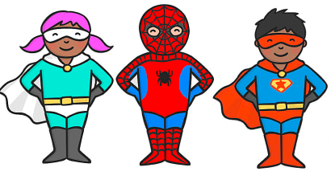

**PE**

* Balance/agility
* Dance
* Master basic movements

**RE**

* Being Special/What does it mean to belong?
* Harvest: A time for giving thanks
* Christian infant baptism

**PSHE**

* Friendship
* How do we show respect for one another?
* Making good choices

**Music**

* Begin to recognise styles
* How pulse, rhythm and pitch work together

**History**

* Historical heroes/Heroines:
* Rosa Parks/ Emily Davidson
* Sporting heroes and heroines