

HATHEROP C OF E PRIMARY SCHOOL

ADMISSIONS POLICY

1. General
Hatherop Church of England Primary School is an inclusive school. Gloucestershire LA is responsible for offering places to all pupils, including those with disabilities and Special Educational Needs.
The admission arrangements described in this document will apply to admissions into Reception in September.
Admissions to Hatherop will be through Gloucestershire Local Authority co-ordinated scheme and its timetable. Parents will need to apply for a place in Reception on the Common Application Form if they wish their child to be considered for a place. The school will admit a maximum of 12 children. Where the number of applications is greater than the published admission number the over-subscription criteria will be applied.

Admission of under 5s
Parents of pre-schoolers should contact the school for information on the application process. Once the LA has allocated a place at Hatherop, the school begins an induction process to smooth integration into school. Under 5s begin on a part-time basis, gradually increasing the length of their school day until they are full-time.

Contact: Admissions and Transfer Team
Address: Gloucestershire County Council
Shire Hall, Gloucester, GL1 2TP
www.gloucestershire.gov.uk/schooladmissions
schooladmissions@gloucestershire.gov.uk
Tel: 01452 425407
Community & Voluntary Controlled Infant and Primary Schools
Community and Voluntary Controlled Primary Schools within Gloucestershire are maintained by Gloucestershire County Council, and the Local Authority is responsible for admissions.
For admission to reception, parents must submit their Common Application Form stating their preferred schools to the Access to Learning Team no later than 15 January 2017.

2. GENERAL OVERSUBCRIPTION CRITERIA
Where applications for admission exceed the number of places available (12 places at Hatherop), the following criteria will be applied, in the order set out below, to decide which children to admit:
1. A 'looked after child' ( 1 ) or a child who was previously looked after but immediately after being looked after became subject to an adoption( 2 ) child arrangements order ( 3 ) or special guardianship order ( 4 ) .
2. Children who will have siblings attending the school at the time the applicant child is admitted.
3. Children with the strongest geographical claim, measured in a straight line from the ordnance survey address point of the child’s home address (including flats) to the ordnance survey address point of the school, using the Local Authority’s computerised measuring system, with those living closer to the school receiving the higher priority.
Where any particular category at points 1-2 above is oversubscribed, criterion 3 (strongest geographical claim based on straight line distance) will be used to determine which child is offered a place.
In the event of a tie between two or more children when applying criterion 3 (strongest geographical claim based on straight line distance) where there are not enough places available to offer all children a place at the school, a process of random allocation will be followed by the Local Authority. This will be in the form of a manual process that is overseen by an independent person from the Council’s Legal Services. Where twins or children from multiple births are part of a random allocation process they will be considered as one applicant.
(1) A 'looked after child' is a child who is (a) in the care of a local authority, or (b) being provided with accommodation by a local authority in the exercise of their social services functions (see the definition in Section 22(1) of the Children Act 1989) at the time of making an application to a school. In Gloucestershire, such children are referred to as Children in Care.
(2) This includes children who were adopted under the Adoption Act 1976 (see section 12 adoption orders) and children who were adopted under the Adoption and Children Act 2002 (see section 46 adoption orders).
(3) Under the provisions of s.14 of the Children and Families Act 2014, which amend section 8 of the Children Act 1989, residence orders have now been replaced by child arrangements orders.
(4) See Section 14A of the Children Act 1989 which defines a ‘special guardianship

3. IN-YEAR ADMISSIONS
In-year applications are all those made outside the normal admissions round for children of compulsory school age i.e. those applications are made during the academic year for any school place in Reception through to Year 6. The Local Authority is no longer responsible for offering places to children on behalf of all schools/academies, but the Local Authority does maintain the statutory duty of being responsible and aware of all pupils and vacancies within schools/academies within Gloucestershire. To apply for a place at Hatherop C of E Primary School, parents should contact the school in the first instance.
The school will consider all such applications and if the year group applied for has a place available, a place will be offered. If a place is not available, the parent can ask for his or her child’s name to be added to the waiting list. Parents whose applications are turned down are entitled to appeal at an independent appeals panel.

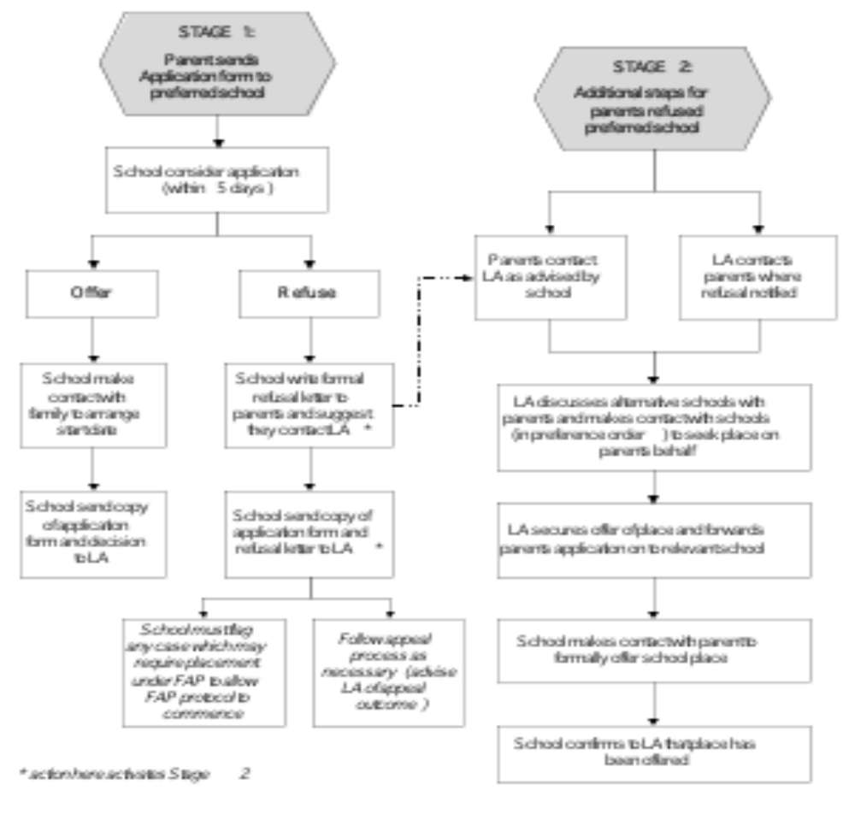

This policy was updated by the Governors in November 2016 and will be reviewed in November 2017.

